A000-Eur-Czech Republic-Moravia-Dolní Věstonice-Figurine-Mammoth-Ivory-26,000 BP

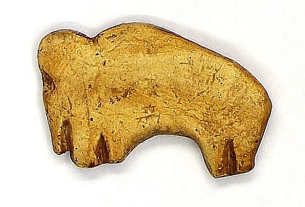

Fig. 1. Czech Republic-Moravia-Dolní Věstonice-Figurine-Mammoth-Ivory-26,000 BP. Replica in resin.

Case No.: 1

**Formal Label:** Czech Republic-Moravia-Dolní Věstonice-Figurine-Mammoth-26,000 BP

**Display Description:**

This ivory mammoth from Dolní Věstonice, Moravia, in the Czech Republic, was found on the hill of Pollau 549 m (1,801 ft) asl, and was dated to 26,000 BP. This site has been a source of figurines of the Gravettian period (27,000-20,000 BP).

**Accession Number:**

**LC Classification:** GN772.22.C95

**Date or Time Horizon:** 26,000 BP C14

**Geographical Area:** Moravia in the Czech Republic, on the hill of Pollau.

Map, GPS Coordinates: 48.88826 16.64364.



Fig. 2. Relief map showing Upper Paleolithic sites along the northeast side of the Pollau Hill. Dark line is the Dyje River.

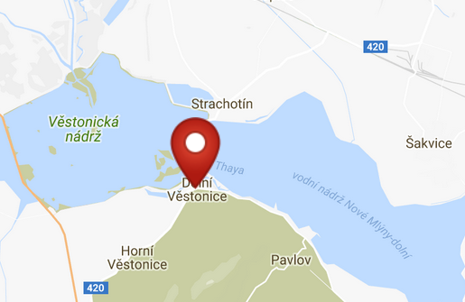 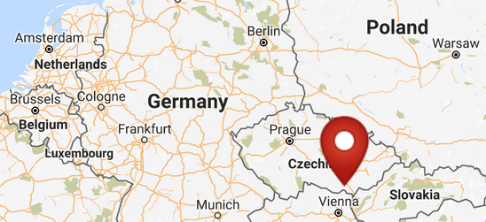

Figs. 3. Map of Dolni Vestonici. Fig,. 4 Map of Dolni Vestonici within Europe. After http://latitude.to/img/latitude-logo.svg

**Cultural Affiliation:** Gravettian period

**Medium:** ivory.

**Dimensions:   
Weight: original, unknown.**

**Provenance:**

**Condition:** museum replica in resin.

**Discussion:**

Dolní Věstonice, Moravia, Czech Republic, is located on Pollau Hill, 549 m (1,801 ft) asl, and dates to the Gravettian period (28,000 BP-24,000 BP). This ivory sculpture of a mammoth provides a glimpse into an Upper Paleolithic depiction of the mammoth as a rationalistic entity.

The sites of Dolni Vestonice and Pavlov were part of an Upper Paleolithic culture that occupied these sites between 28,000 and 24,000 years B.P.

This figurine, because it was carved from ivory, probably was considered to be a permanent portable artifact in contradistinction to the 10,000 broken ceramic artifacts that were fractured in the firing process. Since those thermally fractured ceramic figurines were witnessed by a ritualistic group, this artifact was probably not part of that phenomenon.

**References:**

Trinkaus, Erik and Jiri Svoboda (Eds.) 2005.*Early Modern Human Evolution in Central Europe: The People of Dolní Vestonice and Pavlov* (Human Evolution Series). New York: Oxford University Press.

Vandiver, Pamela B., Olga Soffer, Bohuslav Klima and Jiři Svoboda. 1989. “The Origins of Ceramic Technology at Dolni Věstonice, Czechoslovakia,” *Science*, New Series, 246, No. 4933 (Nov. 24), pp. 1002-1008.